**AJJ BNB User Manual**

Table of Contents

**Introduction 1**

**System Requirements 1**

**Installation Instructions 1**

**Usage Instructions 2**

# Introduction

Thank you for choosing AJJ BNB! We are dedicated to making your life easier when it comes to understanding the Sydney BNB market. This manual will help you understand how to use AJJ BNB.

# System Requirements

No special system requirements are required to use our software.

The minimum required requirements are:

* Operating System: Windows, (Linux is possible)
* Processor: 1GHz Single Core x86
* Graphics Card: Integrated graphics capable of VGA
* RAM: Less than 4GB
* Hard disk space: 1GB
* Screen Resolution: 1280x720p (recommended 1920x1080p)

# Installation Instructions

Assuming the app is run from the command line, there will be a few things required to download to run the app.

1. Python will need to be installed.
2. Ensure pip is installed.
3. The following modules will need to be installed (via pip or somewhere else):
   1. pip install **tkcalendar**
   2. pip install **matplotlib**
   3. pip install **tk**
   4. pip install **pandas**
   5. pip install **numpy**
   6. pip install **mplcursors**

# 

# Usage Instructions

1. **Run the application.**If this is your first time running the application, you will see the following screen:  
   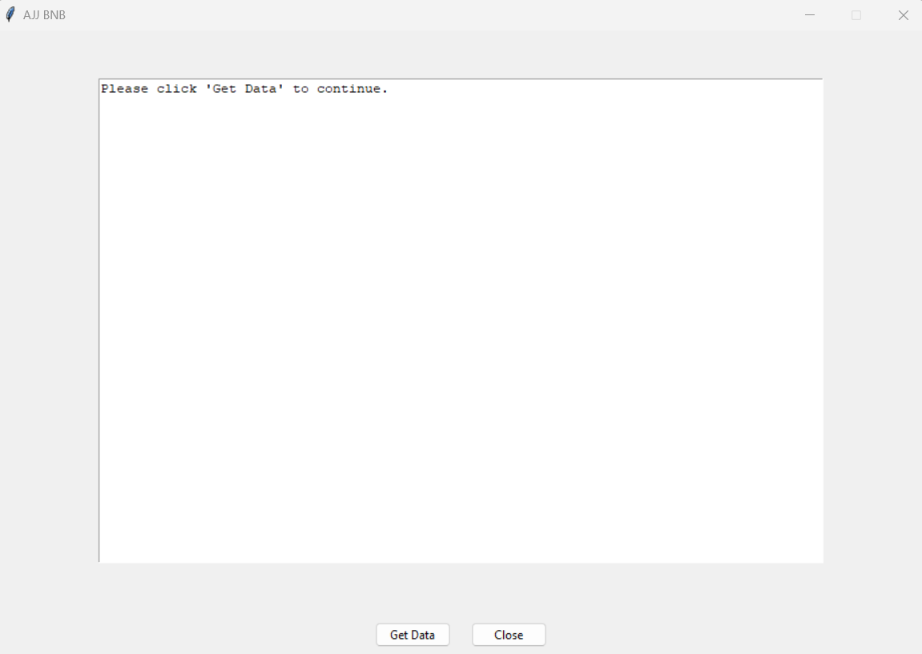  
     
   Click “Get Data” to populate data.db that was created by running the application.The application will now show the following:  
   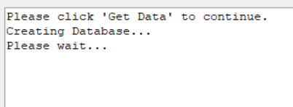  
     
   When the application has finished creating the database, you will see the following:  
   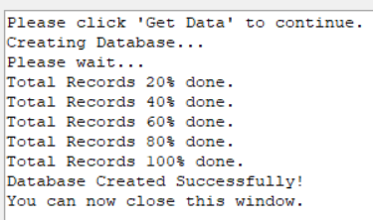  
     
   You may now close this window to get to the next part of the application.
2. **Main application.**

You should now see the following screen:  
 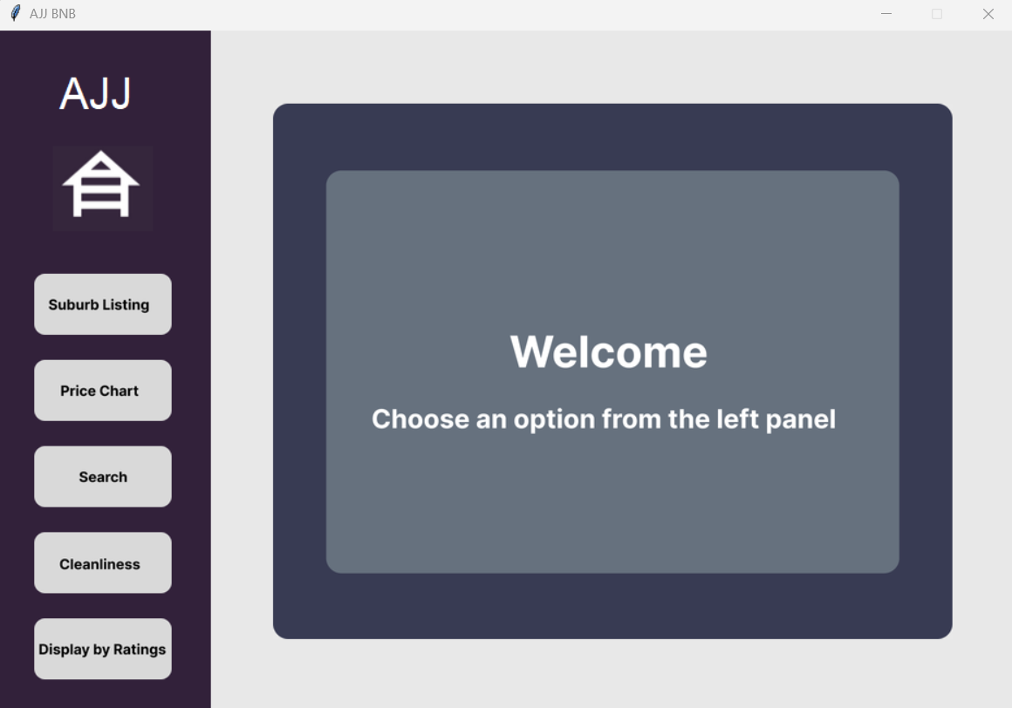

This is the greeting page of AJJ BNB.

The main functionality of the application is accessed by the five buttons on the left hand side. These will be viewable from everywhere in the application.

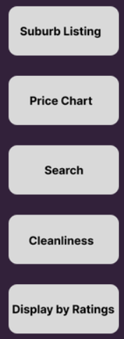

Click any of these buttons, to open a new tab.

1. **Click Suburb Listing**.  
   You should now see the following:  
   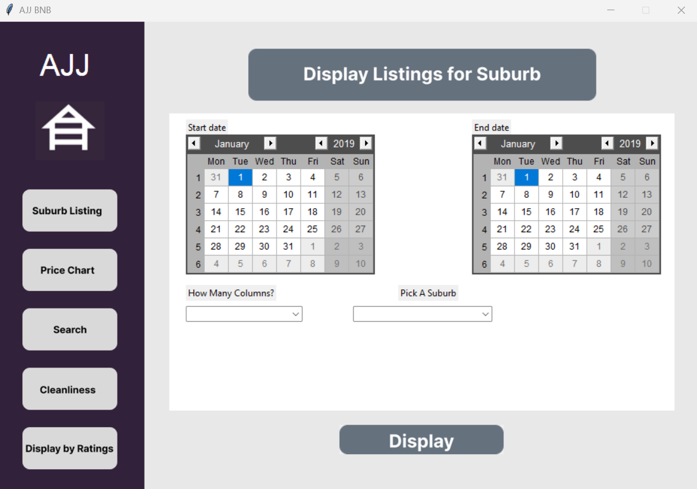  
   Suburb Listing will allow you to see all BNB listings during a certain period for a certain suburb.  
     
   To do this, you must complete the following steps:
   1. Select between two dates by selecting a date on the ‘Start date’ calendar, and the ‘End date’ calendar:  
      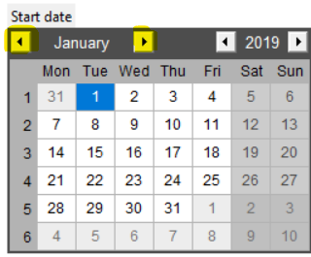 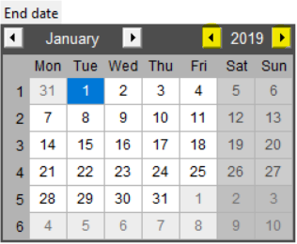  
      The highlighted arrows on the ‘Start date’ calendar, will switch between different months. The left arrow will select the previous month, the right arrow will select the next month.  
        
      The highlighted arrows on the ‘End date’ calendar, will switch between different years. The left arrow will select the previous year, the right arrow will select the next year.  
      *Please note, the data for AJJ BNB only includes 2019 at this stage.*
   2. Select a suburb:  
      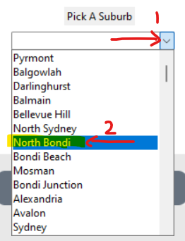  
      Click the right arrow in the select box, and then pick your desired suburb. Your chosen suburb will appear in the box.  
      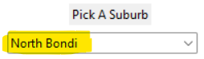  
        
      If you chose the wrong suburb, you can click on the select box, and pick another suburb.  
        
      You can also use the scroll wheel on your mouse, or the scroll bar button, to scroll up and down the suburbs:  
      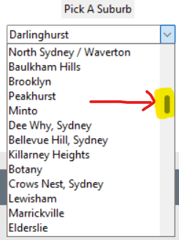
   3. Select how many columns you want, which will change how much data you see for each result. The data will be displayed in a table.  
      There is a ‘Short’ option, or an ‘All’ option.  
      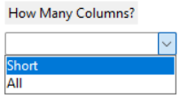
   4. Finally, click the ‘Display’ button.  
      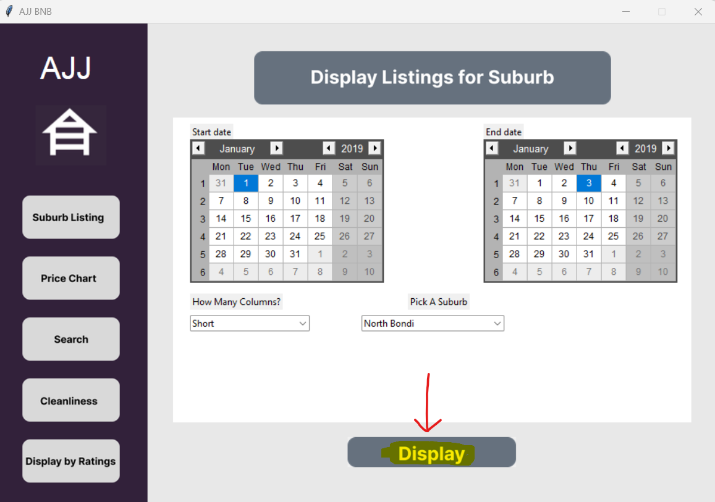  
        
      If you chose ‘Short’ for ‘How Many Columns’, you will see the following:  
      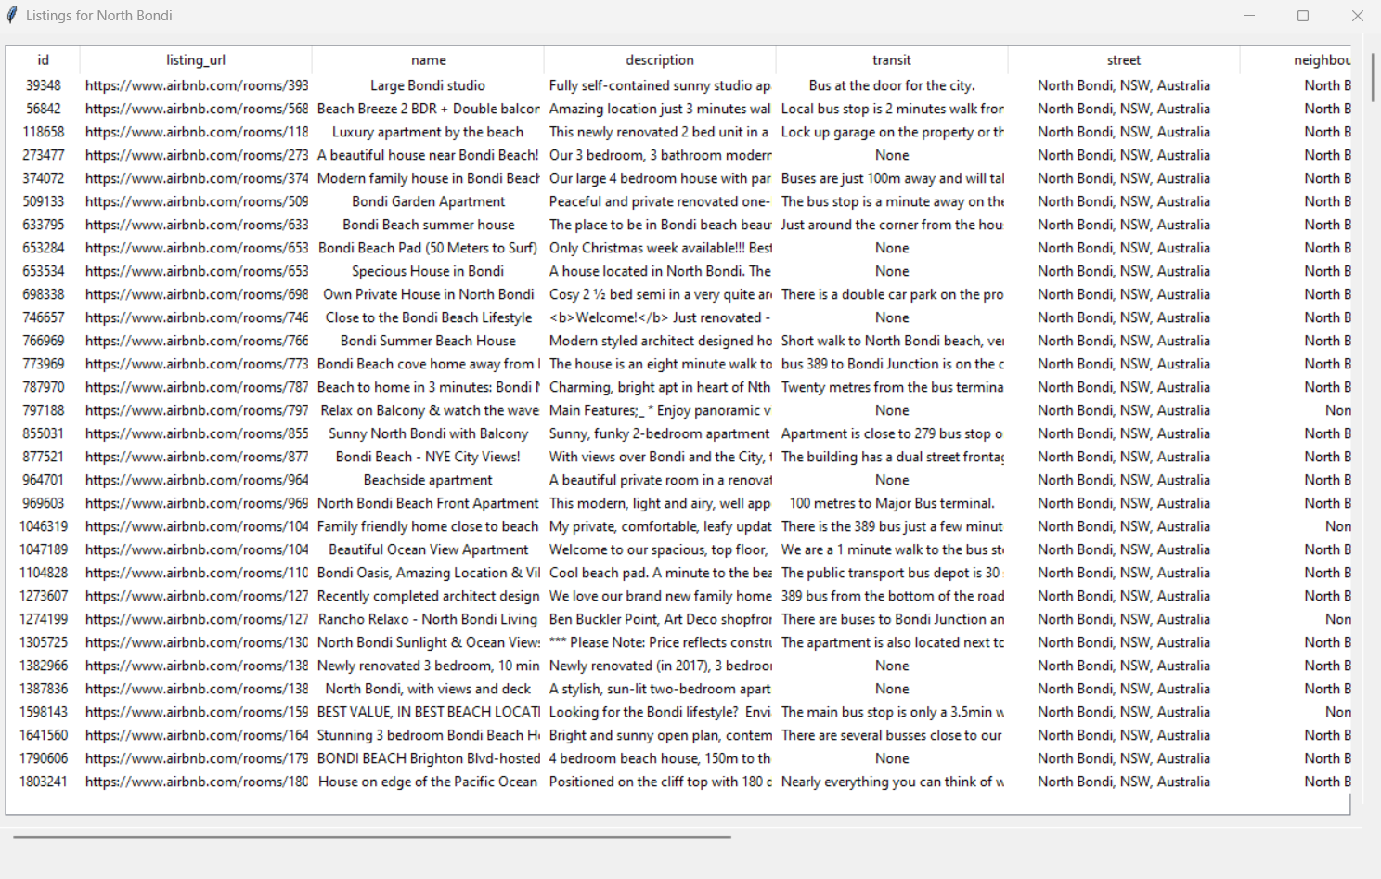  
        
      This is a popup in a new window. The original app will still be available, if you look in your taskbar, you should see the original application window, and the new one:  
      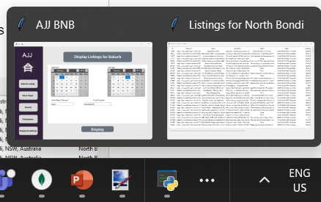  
        
      You will notice that the table is a little laggy. That is because there is a lot of data!   
      This is a smaller list of all the columns that are available in the data. It is all records that fall in the time frame you chose, and the suburb you chose.  
        
      There are two scroll bars, one that goes horizontally, and one that goes vertically:  
      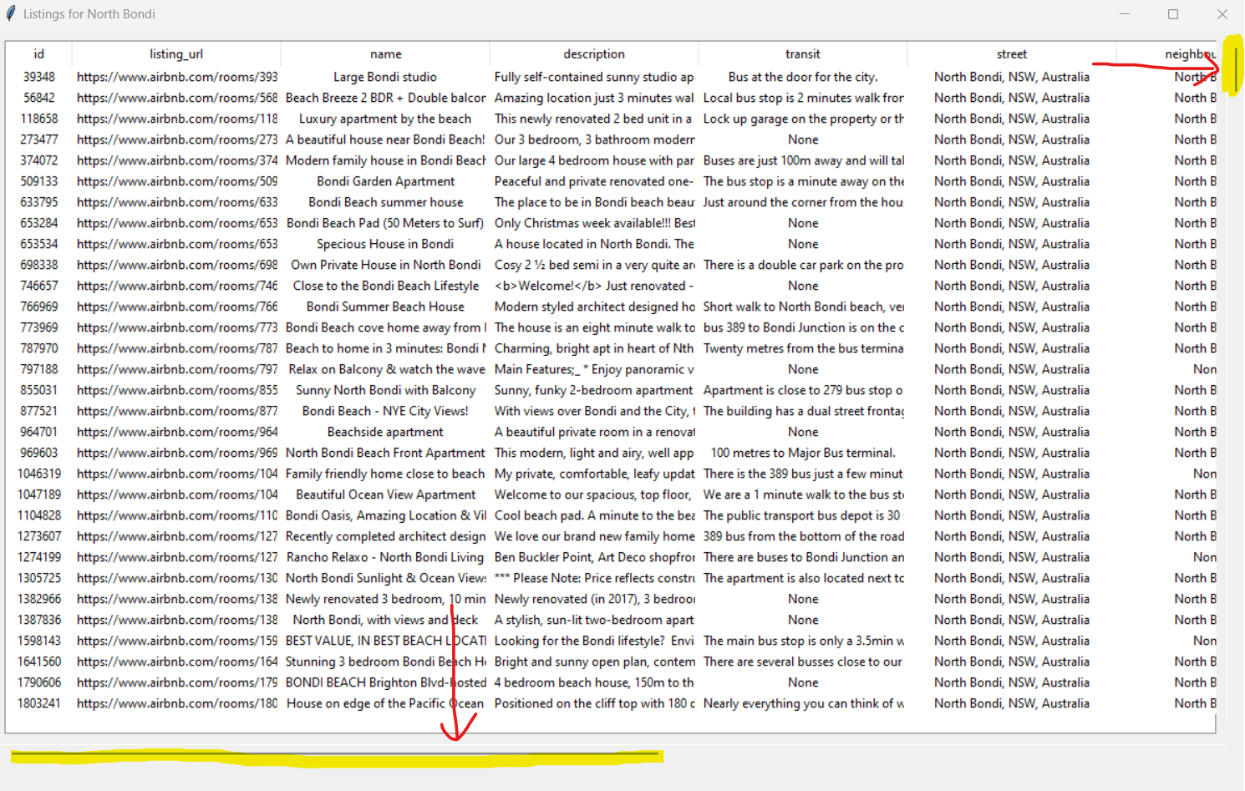  
        
      The horizontal scroll bar will scroll the table to the right, and the vertical scroll bar will scroll the table down. Like so:  
      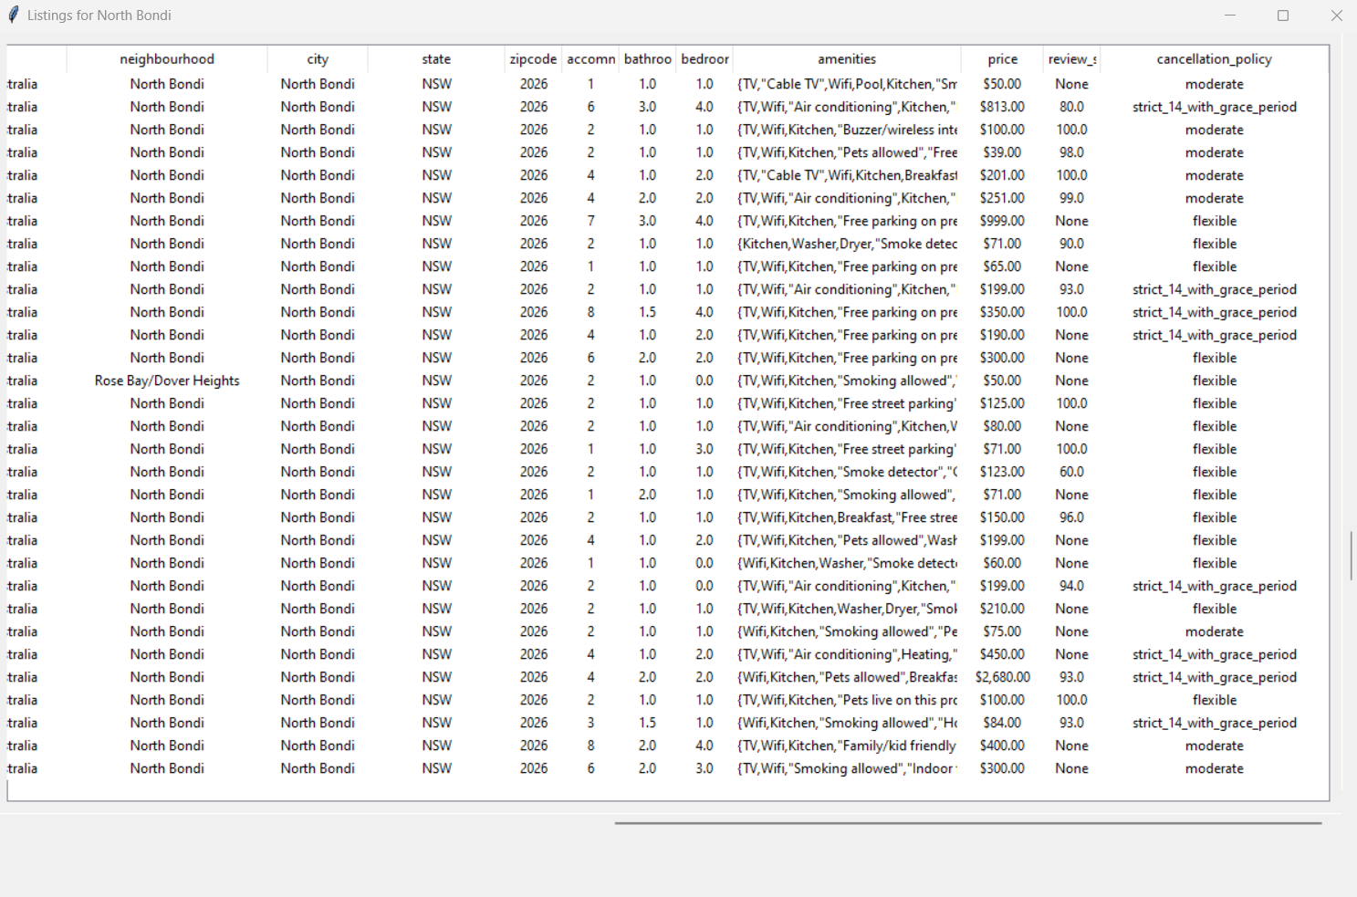  
        
      If you select “All”, you will now see more columns:  
      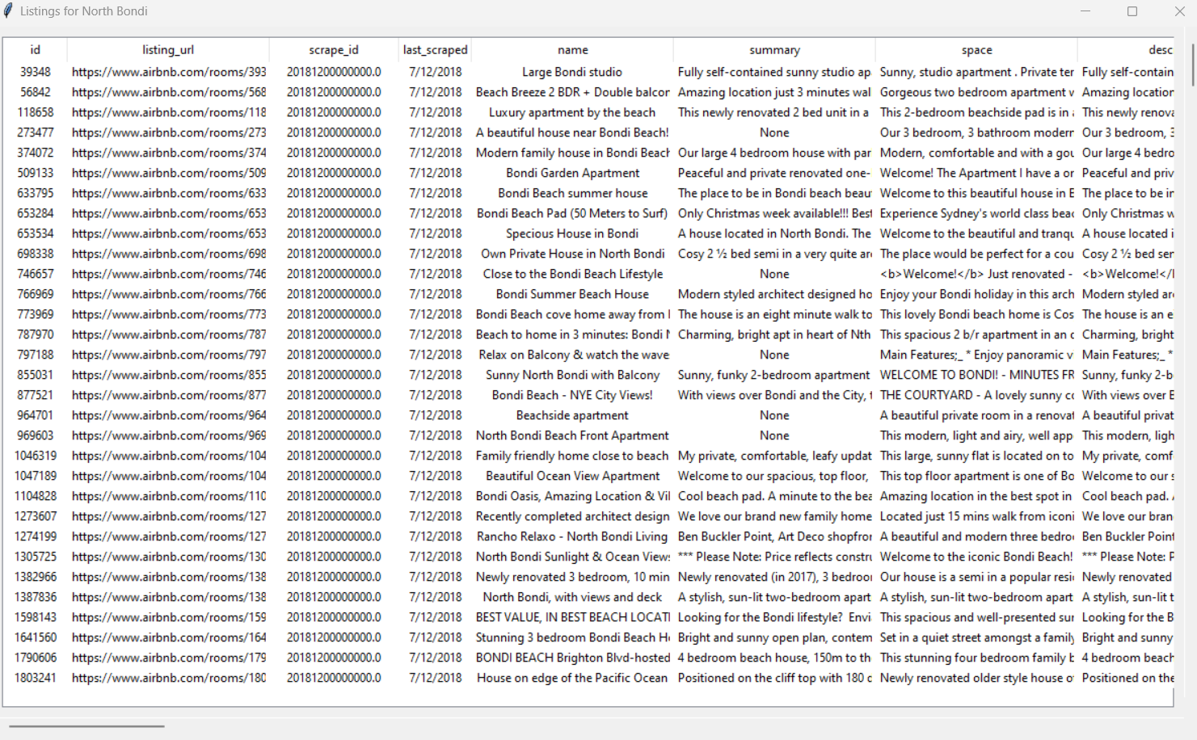  
      You will still be able to scroll vertically and horizontally. Do note, it is even more laggy, because there are even more columns.
2. **Click ‘Price Chart’.**You should now see the following: 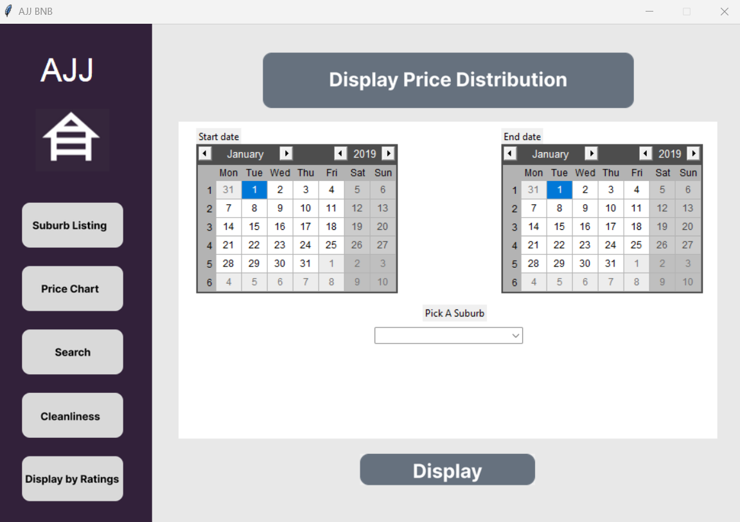Price Chart will allow you to see all BNB listings price costs during a certain period for a certain suburb in a chart.  
   To do this, you must complete the following steps:
   1. Select between two dates by selecting a date on the ‘Start date’ calendar, and the ‘End date’ calendar:  
         
      The highlighted arrows on the ‘Start date’ calendar, will switch between different months. The left arrow will select the previous month, the right arrow will select the next month.  
        
      The highlighted arrows on the ‘End date’ calendar, will switch between different years. The left arrow will select the previous year, the right arrow will select the next year.  
      *Please note, the data for AJJ BNB only includes 2019 at this stage.*
   2. Select a suburb:  
      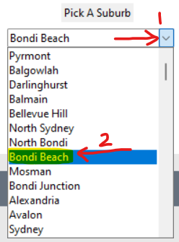  
      Click the right arrow in the select box, and then pick your desired suburb. Your chosen suburb will appear in the box.  
      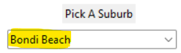  
        
      If you chose the wrong suburb, you can click on the select box, and pick another suburb.  
        
      You can also use the scroll wheel on your mouse, or the scroll bar button, to scroll up and down the suburbs:  
      
   3. Finally, click the ‘Display’ button.  
      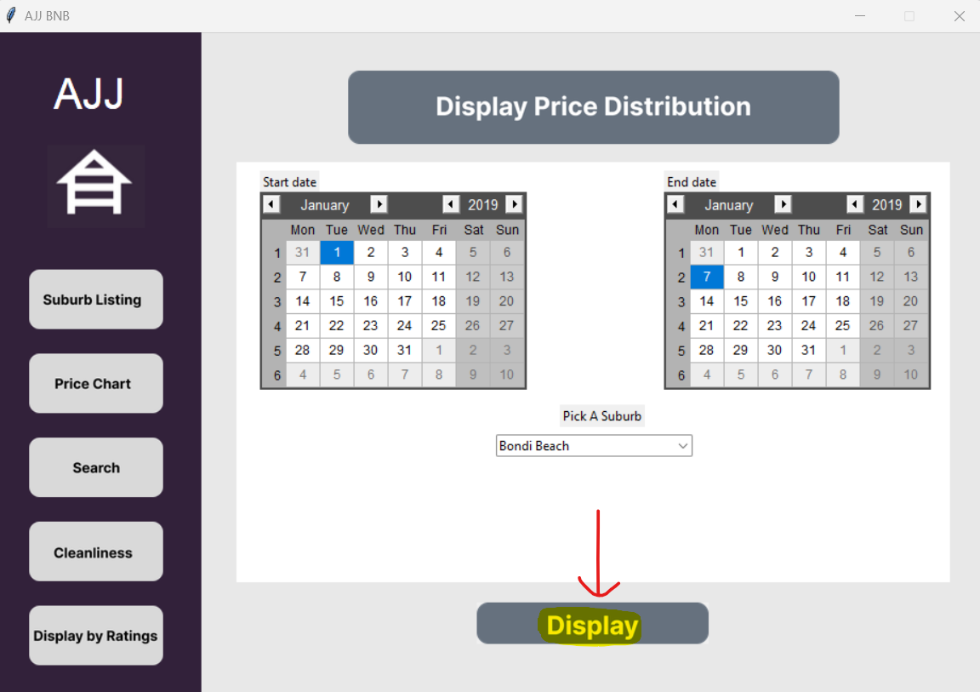  
      You will see a chart like this popup in a new window:  
      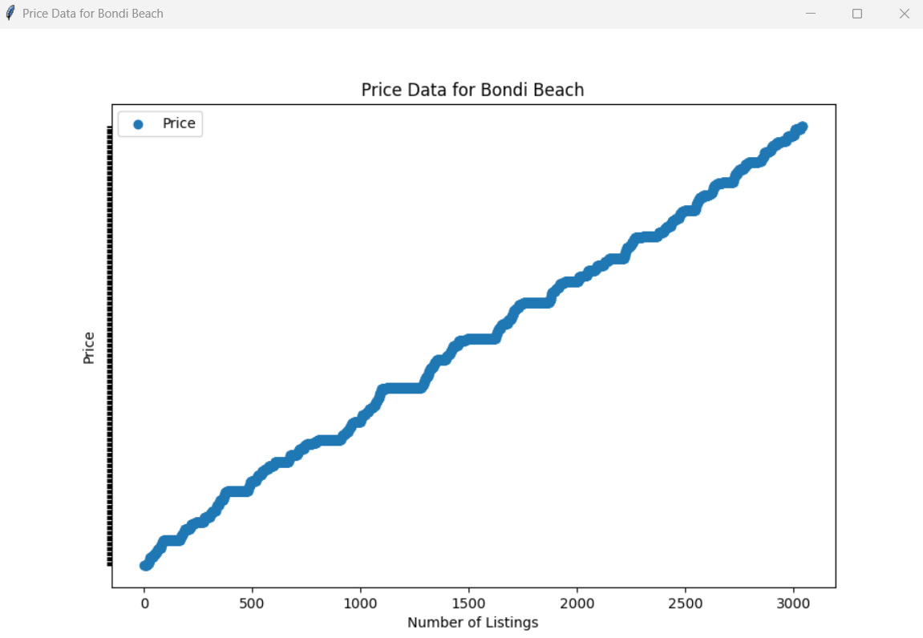  
      It is all price results plotted on the chart.  
      If you hover over a price, you will see the price, the name of the BNB and the date of the price.  
      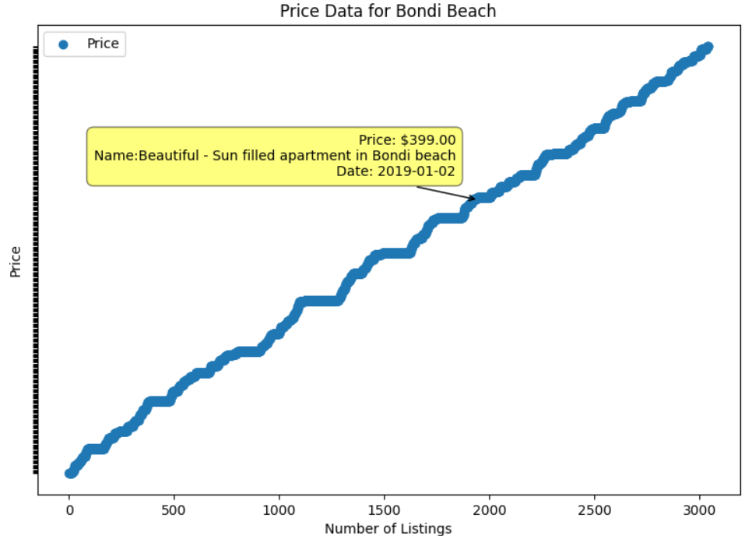
3. **Click ‘Search’.**You should now see the following:  
   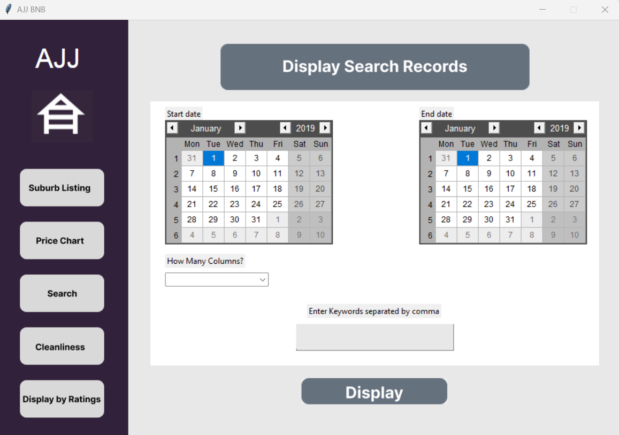  
   Search will allow you to see all BNB listings during a certain period that have amenities relating to keywords you enter.

To do this, you must complete the following steps:

* 1. Select between two dates by selecting a date on the ‘Start date’ calendar, and the ‘End date’ calendar:  
        
     The highlighted arrows on the ‘Start date’ calendar, will switch between different months. The left arrow will select the previous month, the right arrow will select the next month.  
       
     The highlighted arrows on the ‘End date’ calendar, will switch between different years. The left arrow will select the previous year, the right arrow will select the next year.  
     *Please note, the data for AJJ BNB only includes 2019 at this stage.*
  2. Add the keywords you would like to find, comma separated. The results returned will return one of the listed keywords.  
     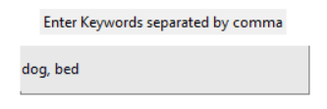
  3. Select how many columns you want, which will change how much data you see for each result. The data will be displayed in a table.  
     There is a ‘Short’ option, or an ‘All’ option.  
     
  4. Finally, click the ‘Display’ button.  
     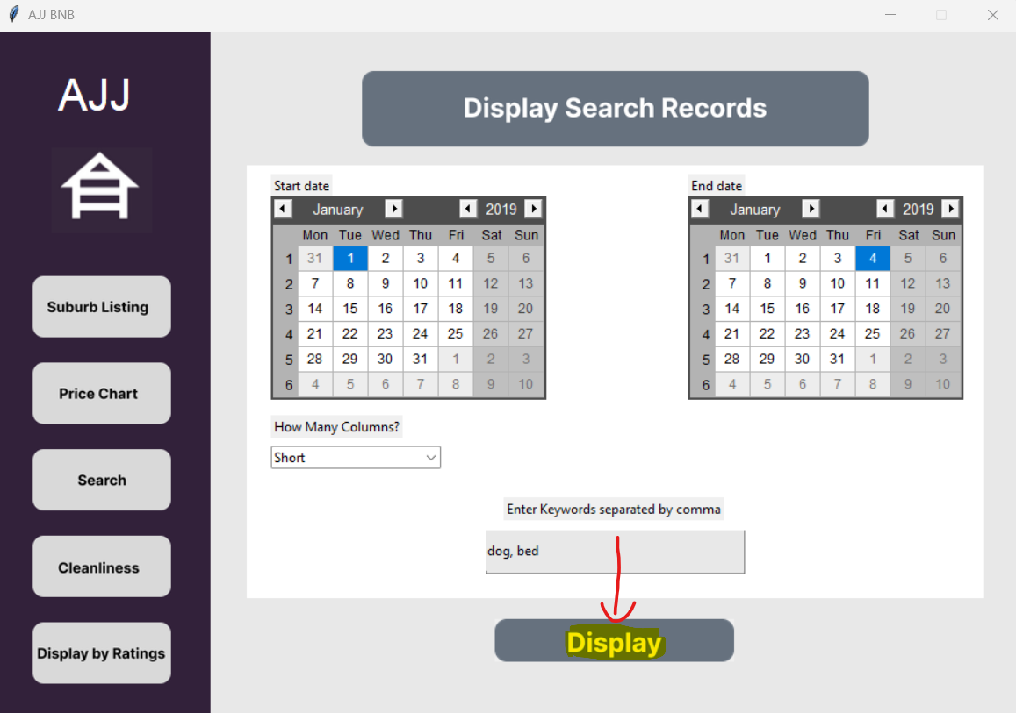  
       
     If you clicked “Short” you will see the following:  
     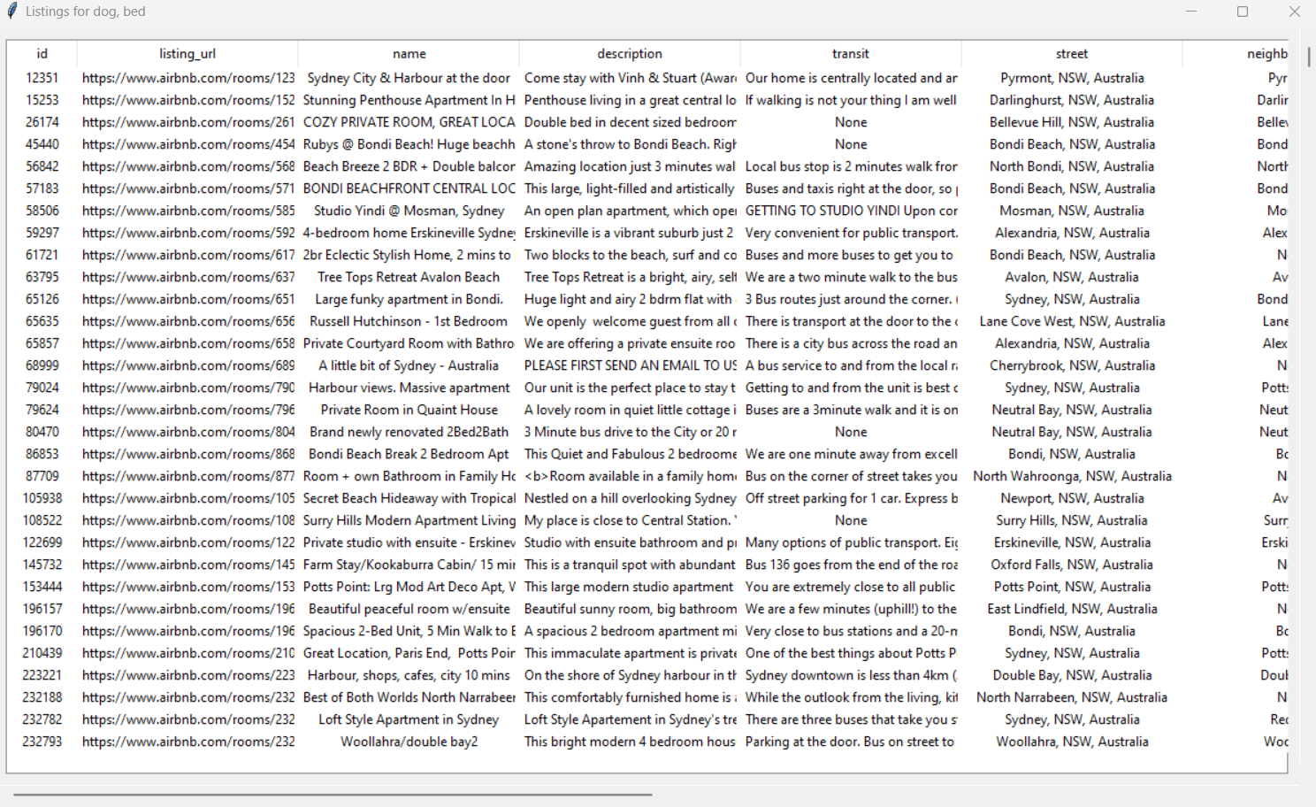  
     You will see results for listings for your chosen dates, with listings that have amenities with your chosen keywords.  
     Like with the suburb listings, you can scroll vertically and horizontally.  
       
     If you choose “All”, you will see all columns:  
     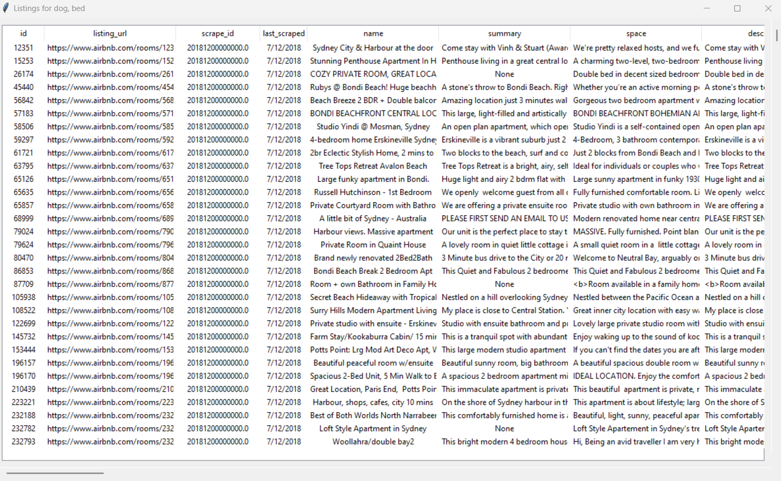

1. **Click ‘Cleanliness’.**You should now see the following:  
   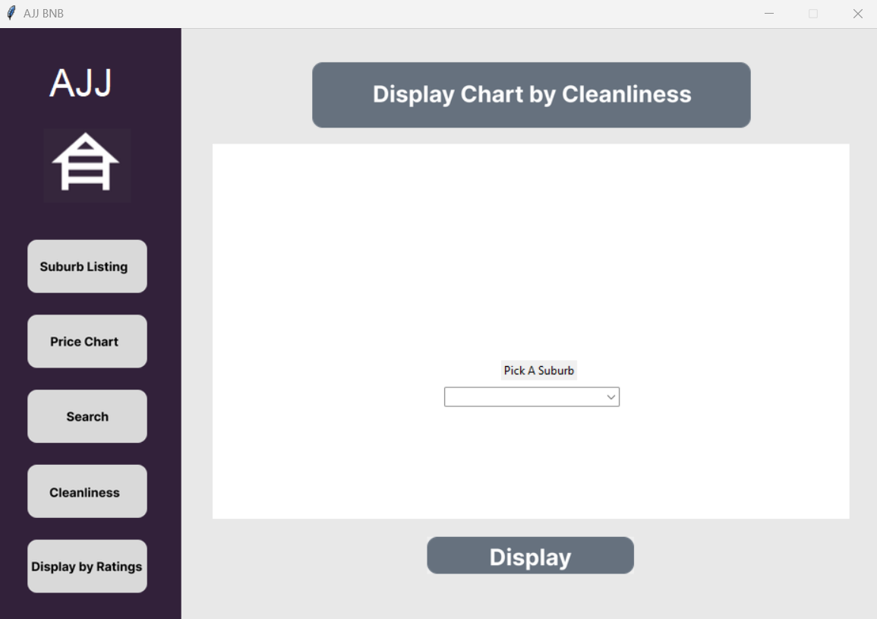  
   Cleanliness will allow you to see a total of all reviews, and all reviews in a table, that mention any of the following keywords: 'dirty', 'clean', 'cleanliness', 'disgusting', 'disgust', 'mold', 'neat', 'filthy', 'fresh', 'spotless', 'dust', 'germ', 'immaculate', 'tidy', 'hygiene', 'hygenic', 'gleaming', 'unsoiled', 'sanitary', 'contaminated', 'mop', 'vacuum' , 'decontaminate', 'orderly', 'rinse', 'cob', 'cobwebs', 'rodents', 'rodent', 'vermin', 'mice', 'mouse', for a certain suburb.  
     
   To do this, you must complete the following steps:
   1. Select a suburb:  
        
      Click the right arrow in the select box, and then pick your desired suburb. Your chosen suburb will appear in the box.  
        
      If you chose the wrong suburb, you can click on the select box, and pick another suburb.  
        
      You can also use the scroll wheel on your mouse, or the scroll bar button, to scroll up and down the suburbs:  
      
   2. Finally, click the ‘Display’ button.  
      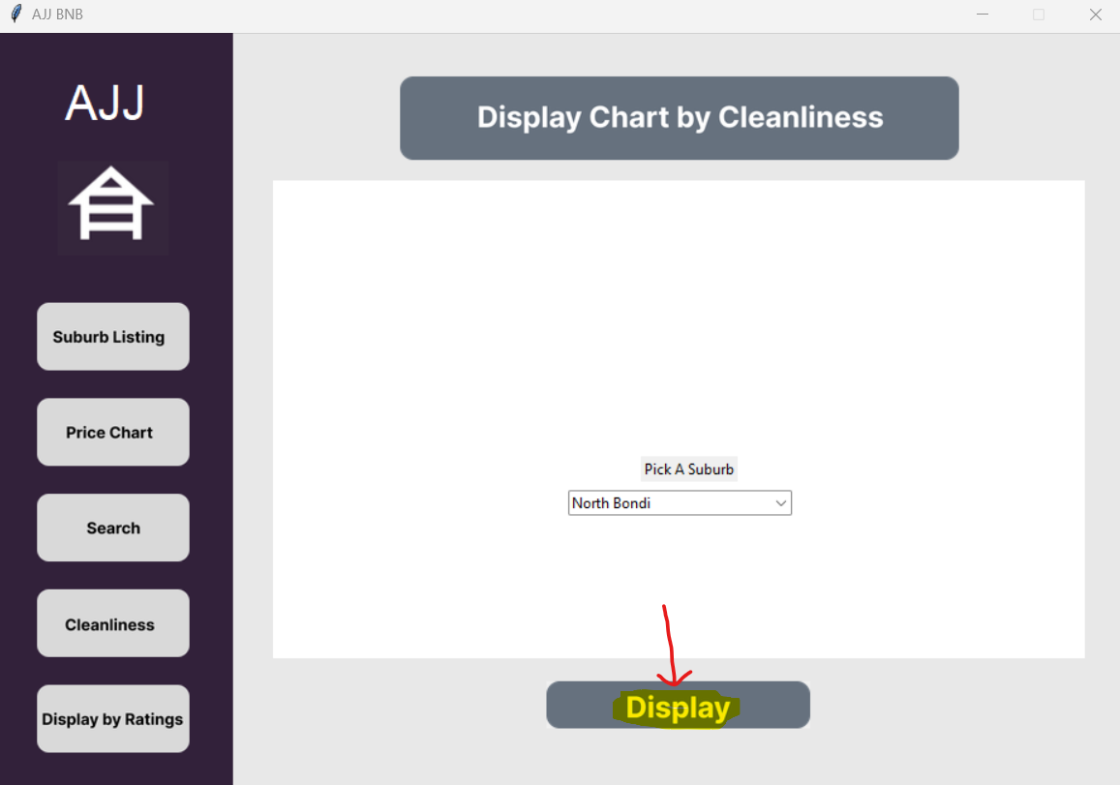  
      You will need to wait a few seconds for the application to process the request.  
        
      You will then see this screen popup:  
      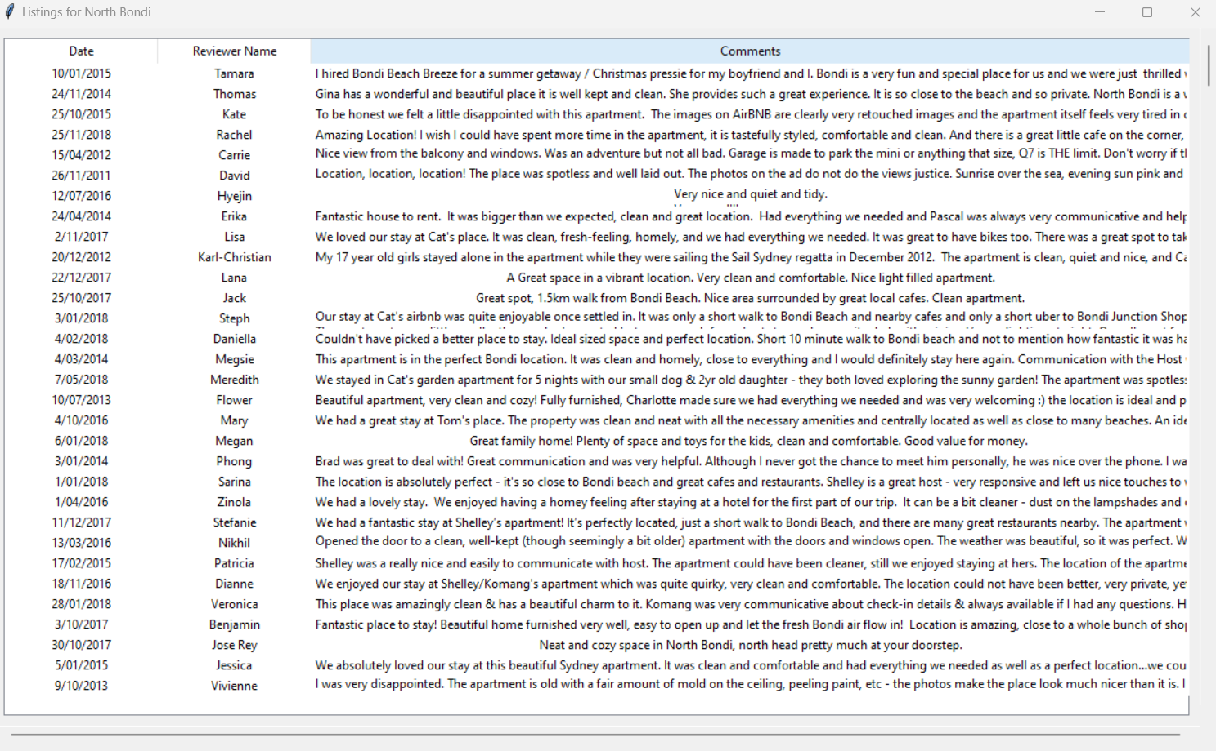  
      It shows the date of the review, the reviewer’s name, and the comment/review the reviewer left. You can also scroll horizontally and vertically.  
        
        
      If you click back on the main app, you will also see the following result:  
      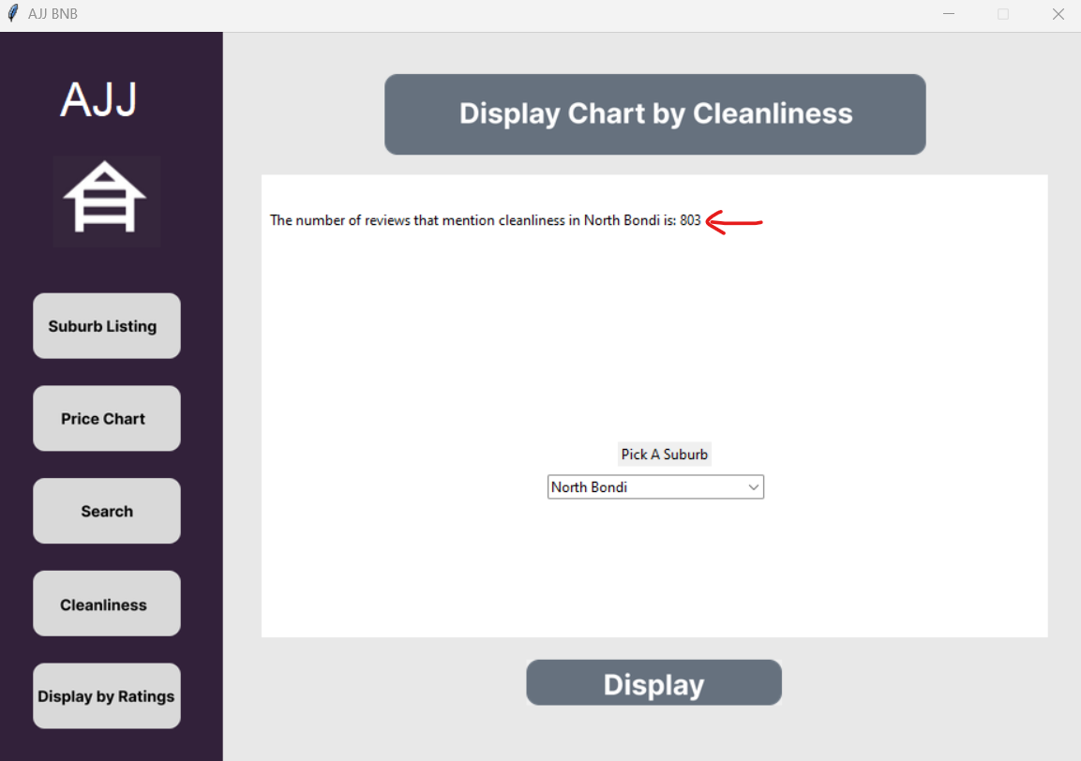This is the count of all the reviews that are for the suburb, and mention the keywords.
2. **Click ‘Display by Ratings’.**You should now see the following:  
   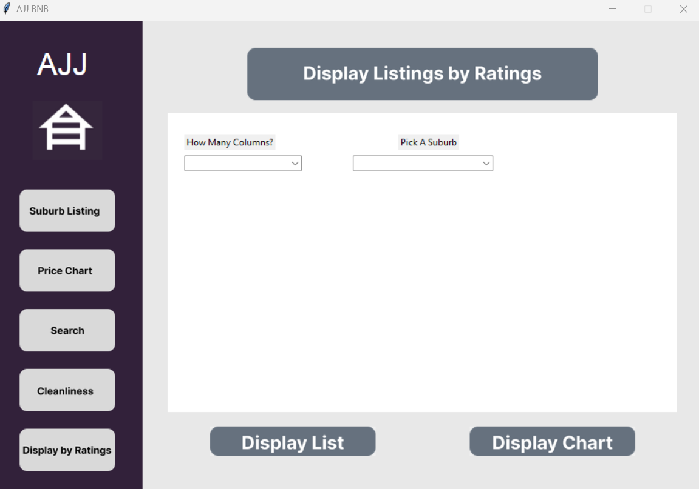  
   Display by Ratings will allow you to see all BNB listings for listings with ratings over 75, for a certain period. You will be able to see a table of the results, or a chart of the results.  
     
   To see the table of results, you must complete the following:
   1. Select a suburb:  
        
      Click the right arrow in the select box, and then pick your desired suburb. Your chosen suburb will appear in the box.  
        
      If you chose the wrong suburb, you can click on the select box, and pick another suburb.  
        
      You can also use the scroll wheel on your mouse, or the scroll bar button, to scroll up and down the suburbs:  
      
   2. Select how many columns you want, which will change how much data you see for each result. The data will be displayed in a table.  
      There is a ‘Short’ option, or an ‘All’ option.  
      
   3. Finally, click the ‘Display List’ button.  
      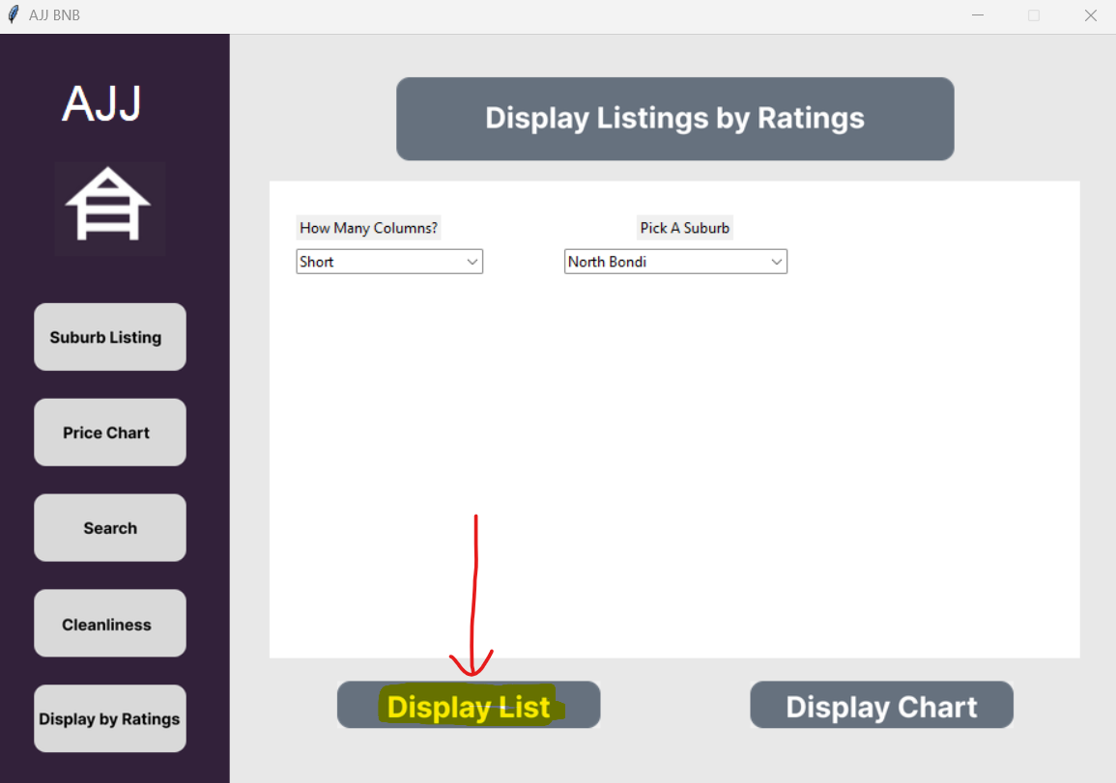  
        
      You will now see the following results in a new popup window:  
      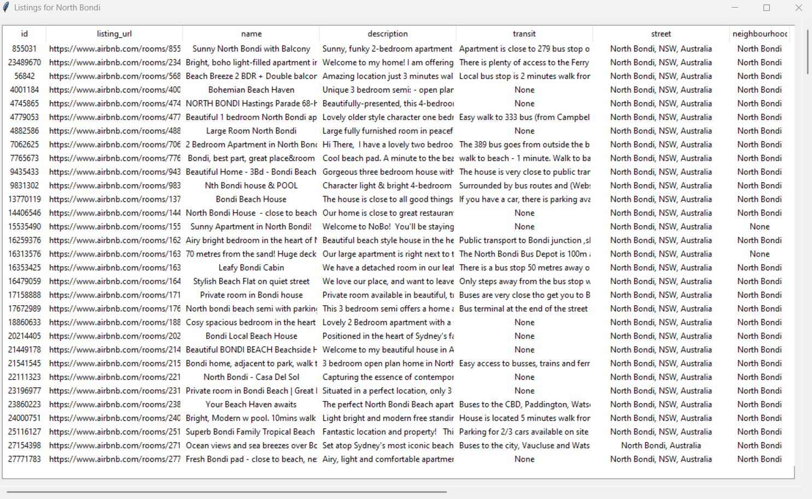  
      These are all the suburbs with ratings above 75 shown in a table.

To see the chart results, you must complete the following:

* 1. Select a suburb:  
       
     Click the right arrow in the select box, and then pick your desired suburb. Your chosen suburb will appear in the box.  
       
     If you chose the wrong suburb, you can click on the select box, and pick another suburb.  
       
     You can also use the scroll wheel on your mouse, or the scroll bar button, to scroll up and down the suburbs:  
     
  2. Click the ‘Display Chart’ button.  
     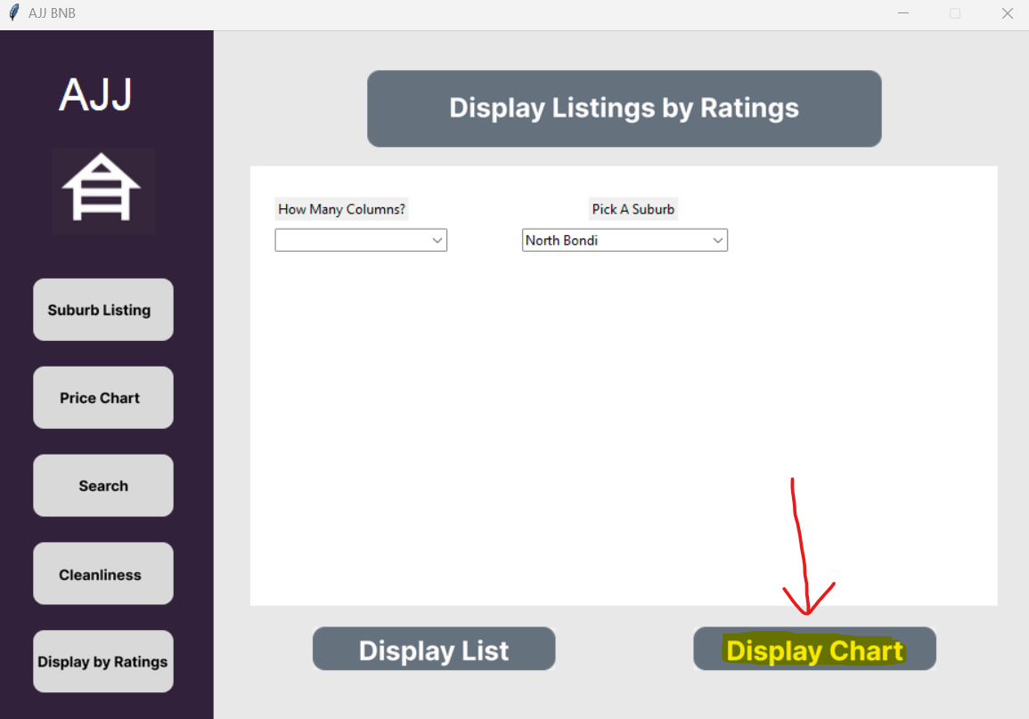  
     You will now see the following results:  
     